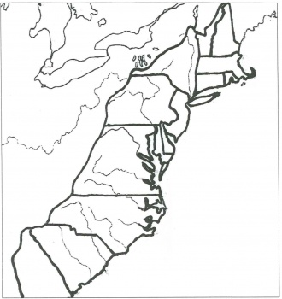
13 Colonies Map Activity
- Find New York on the map and put your finger on it. Now color New York green.
- Find Massachusetts on the map and color it red
- Find the area that is between New York and Massachusetts and put your finger on it. This area is called New Hampshire. Label it in pen and then color it yellow.
- Find Massachusetts on the map and put your finger on it. Go directly south and you will find a small area called Rhode Island. Color it pink.
- From Rhode Island, go directly west. This area is called Connecticut. Color it purple.
- Find New Jersey on the map. It is south of New York, on the Atlantic Coast. Color this state orange.
- Find the area that is south of New York, but west of New Jersey. Label this area Pennsylvania in pen and color it blue.
- Directly south of New Jersey, is Delaware. Color this area red.
- Find Virginia on the map. Color this area with yellow stripes.
- Find the area north of Virginia. This is Maryland. Color it green.
- Directly South of Virginia is North Carolina. Label this area in pen and color it with horizontal orange stripes.
- The area at the southern most point of our map is called Georgia. Color this area with purple polka dots.
- Find the area north of Georgia and south of North Carolina. What area is this? Label it and color it blue.

13 Colonies Mnemonics
Directions: Illustrate a picture for the following mnemonic:
There's a cow named Georgia (Georgia)
It’s wearing a Jersey (New Jersey)
She's sitting on top the empire state building ( New York)
Singing a couple of Christmas carols (n & s Carolina)
Under her arm is a Virginia Ham (Virginia and New Hampshire)
The cow is wearing yellow underwear (rhymes with Delaware)
In its hoof is a pencil (Pennsylvania)
The cow is making a connect-the-dots drawing (Connecticut)
of a girl named Marilyn (Maryland)
Walking down a road (Rhode Island)
Going to mass (Massachusetts

